DRC-2 digital receiver

Main feature:

2 line cards (Telephone, Radio communicate)
- External DC12V power supply or 12V DC battery backup
- Inside 6V DC battery charger with programmed current (for 6V -1.3Ah, 4Ah, 7Ah)
- Low consumption, long action from battery. (6V-4Ah more 30 hours)
- Inside real time clock. (Y2K compatible).
- Event buffer (max: 4000 events in NVRAM)
- Parallel printer output (printing the events)
- Programme printing working
- Standard serial protocol (Basic + Clock signal)
- Programming with serial port all parameter, and program update (FW Update)
- Multi - link option, for connecting other DRC-2 (just up the 1.0.11 version )
- Inside buzzer with different signal and programmed working mode
- Acknowledge button .
- Different colour LED for the functions signals
- Programmed (OC) output for the trouble signals.
- Programmed input (tamper or ACK)
- Easy install, small box

Where to use the DRC-2 digital receiver?

The DRC-2 ideal equipment for the small local monitoring systems. For the bigger system install whit optional multi-link function.
Ideal for:

- Reserve systems
- Local building monitoring
- Technical monitoring systems (for installers)
- Monitoring systems

Front panel
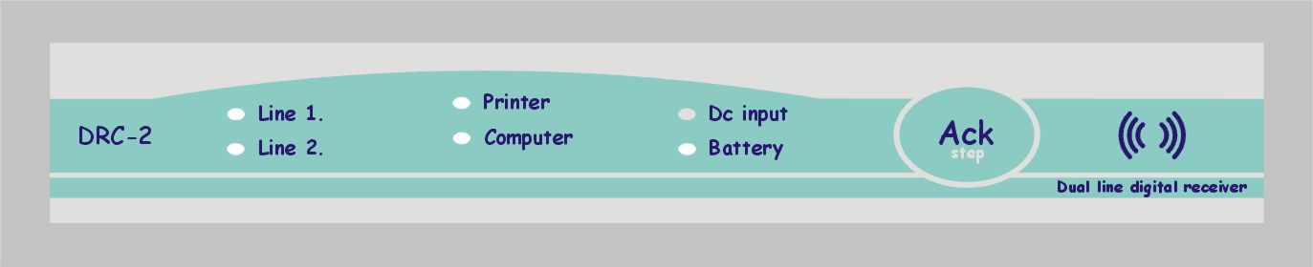
Line status
Green:
- Tel. line is OK
Flashing green:
- Pick up line
Yellow:
- received data
Red:
- Line error
Printer status:
Green:
- Printer is OK
Red:
- Printer error (out of paper or offline)

RS232 status:

Green:
- PC conect is OK
Yellow:
- Wait ACK
Red:
- Disconnect the PC
6V Battery status:
Green:
- Battery is OK
Yellow:
- Charged
Red:
- Battery is low voltage

DC12V input status:
Green:
- 12V DC OK
Red:
- Low voltage
Acknowledge button
Short:
- ACK
Long (8 beep):
- DRC-2 restart (reset)

Internal buzzer:

Programming the buzzer:
- Always OFF
- Always ON
- Just in „offline” mode enable.

If the buzzer is enable, then programmed the received events signals one short signal mean good data (wrong data is two long signals).

Different signals reports:
- Short high-pitched: ACK button signal or new event received
- Two low signals: System trouble (Flashing RED LED(s) repeat for the ACK , or ban data format.
- 1 min repeat low signal: Real time clock not adjustable

If the buzzer is enable, then the new errors make flasdhing red LED signals. After the manual ACK the flasing red LED(s) changed continuous red light and the buzzer cut off.

ACK button:

The ACK is multi-functions:
- Short pushing is acknowledge.
- Continuous pushing (2 sec after, 1 sec) repeat short signals change the menu. After eight buzzer signal receiver is restart. (reset)

Back panel
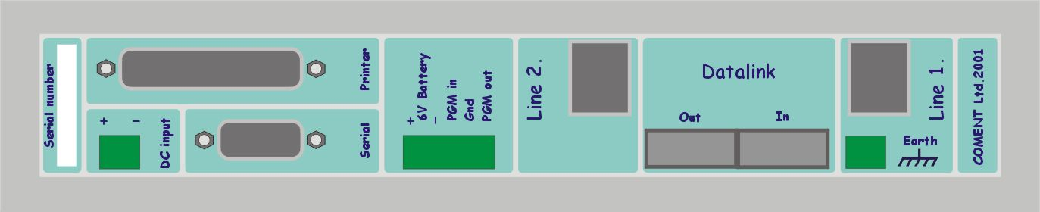
Printer output
6V battery terminals
(1.3Ah, 4Ah, 7Ah)
PGM input
- Internal ACK button
- Tamper input
Alarm (NC), Restore(NO)
PGM output
- Open collector max. 100mA curent .
DC 12V input
- Internal power supply.
RS232 serial connector
- programming.
- PC connecting
- Program update
Datalink for other
DRC-2

Earth for lighting protection
Line input (1,2)
- Telephone line
- Radio receiver

DC input
For connecting the external 12V DC power supply. Input 11 – 20V DC. If the voltage lower 11Volt the receiver signal trouble.

Maximum current :

1.3Ah 70 - 250mA (Simple power supply for example: ICA12-500PC)
4Ah 70 - 500mA
7Ah 70 - 900mA

The input is protected inverse connected.

6V Battery

Very important: Just 6 V battery use!!!

This terminal is just for battery!
Protected inverse connected and short-circuit. The receiver is cut off the wrong connection.

PGM input

Sense the PGM in and GND short-circuit.

PGM output

A PGM out is open collector max. 100mA current If the output is active switched the (GND). The 100mA is enough small internal buzzer or magnet switch. (Connected the buzzer or other goods between for the PGM OUT and 12V DC IN plus terminal).

Serial

RS232 for the PC The format is next:

9600 baud, 7bit + even parity, 1 stop bit

Printer

Parallel printer output (40 or 80 character / line). The printing mode is programme. The printer must the next feature::

- STROBE input
- DATA1-8 input
- ACKNLG output
- BUSY output
- PE output
- ERROR output

Data link

This is other DRC-2 connecting terminals. (This version not use this feature)

Line 1,2

Line input. Telephone line terminal is standard.

Earth

This terminal is for the lighting protection. Must connecting a good earth point,

How to Install the DRC 2 ?

- Connecting the 12V DC supply the terminal blocks. (12V DC INPUT)
- Connecting the serial cable to the DRS-2 and the PC. (Very important the PC connect for the real time clock adjustments).
- Connecting the printer (if you want use printer).
- Connecting the battery cable to the DRC-2 (5 pole terminal), and not now connecting the 6 V battery .
- Connecting the telephone line (Line 1 or Line 2)
- Connecting the 12V DC supply for the mains.
- On the front panel all LED yellow lighting, and after 2 second the system start up.
- The „Line 1,2” ligting green, if not line card the LED not lighting.
- The printer, (if enable) „Printer” LED lighting green. If the printer disable the LED not lighting. The printer test 1 min long .
- A „Computer” LED lighting yellow (the DRC 2 send data to PC but the PC not send ACK to DRC-2). After 10 sec the LED lighting flashing red and repeat buzzer signal warning the PC disconnect. If the monitoring software is run and the connect is good the LED change green.
- A „DC input” lighting green the 12 V DC OK.
- A „Battery” 6V lighting green. Connecting the battery terminal to a 6V battery (be carefull the red is + the black is -). If the battery is charged the LED lighting green (the1.3Ah battery is OK this 12V DC power supply))
- If push the ACK button the buzzer is cut off.
- Started the „DRCConfig” program, and programmed the time and other parameters. (The time is programmed to ÖrMe monitoring software too.).
- Exit the DRCConfig program and started the monitoring software (If you use other monitoring program the serial protocol is 9600, 7 + Even Parity ).

The receiver is already receiving the events.

The DRC-2 restart is delete the event buffer and reset the real time clock because the programmed parameter is do not delete. The line cards parameters just after reset send the DRC-2 to the line cards. Other parameters is immediately valid. (The next program version no must make a restart)

Printer format

The DRC-2 usually use with PC but all event can printing. The events are two parts receiver status or received events. (Account number is 0000, line number is 0 and received reports.)

System events:

11:16:58-07/02 0000-D0 Reset

- 11:16:58-07/02 hour : min : sec – day / month
- 0000-D0 account (receiver) – Event code
- Reset System event short name
- 01-0 Receiver number (always 01) – line number (in system always 0)

Basic protocol (4/1 – 4/3):

19:22:44-07/02 1234-58 P(4/2) 01-1

- 19:22:44-07/02 hour : min : sec – day / month
- 1234-58 Account – Event code
- P(4/2) Line format Pulse 4/2 (P – Pulse, DT – DTMF)
- 01-1 Receiver number (always 01) – line number (1 or 2)

Contact ID protocol:

14:36:14-07/02 1234-E130 z002g01 01-1

- 14:36:14-07/02 Hour : Min : Sec – Day / Month
- 1234-E130 Account – Event code
- z002g01 z – zone number, g – group number
- 01-1 Receiver number (always 01) – line number (1 or 2)

Debug protocol:

11:57:14-07/02 ?(2341816A2A1AAA) 01-1

- 11:57:14-07/02 Hour : Min : Sec – Day / Month
- ?(2341816A2A1AAA) ?(unknown digit )
- 01-1 Receiver number (always 01) – line number (1 or 2)

