DRC2 digital receiver config software

Started the program
The program is one part.: the „DrcConfig.exe” software. Start the program in the program manager. The program icon is the next:

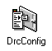

How to use the program?
After the program started the following windows appear:

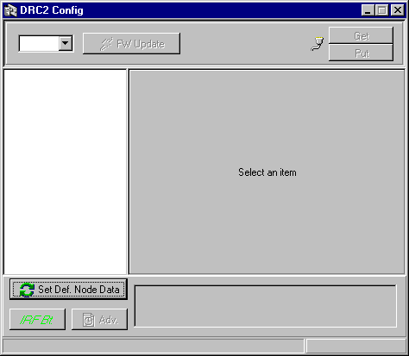
DrcConf program main windows
The main windows stand five parts. In the header look the program name.
In the second stripe look the ComboBox here to choose the used com port. This port connect the DRC2. After the port choose the PC immediately try to communicate with DRC2l, if it is successful write in the status line the version number and two button to be usable. he first button is the program upgrade button:
If this choose to be upgrade the receiver software.
The second button is read the receiver configuration:
The program read the configuration from receiver and represent this. The PUT button is download the config data to receiver:
In the third part look the active configuration. In the left side look in three structure the configuration brand. In the right side look the features. The data modify to be config the receiver.
In the 4.th part look in left side three button. The higher set all parameters default.

If push button in the choose object set default.

If you want look program feature push this button:.

Push „Advanced” button and you look the receiver time or set this and can restart the receiver.
The 5.th part look the program status line. Here look the status and the communicate.

